TITLE PAGE

**Patterns of influence in wild moving meerkat groups (working title)**

Baptiste Averly1,2,3,, Vivek H. Sridhar2,3,, Vlad Demartsev1,2,3,4, Gabriella Gall1,2,3,4,5, Marta Manser4,5,*, Ariana Strandburg-Peshkin1,2,3,4,*

1. Department of Biology, University of Konstanz, Konstanz, Germany
2. Department for the Ecology of Animal Societies, Max Planck Institute of Animal Behavior, Konstanz, Germany
3. Centre for the Advanced Study of Collective Behaviour, University of Konstanz, Konstanz, Germany
4. Department of Evolutionary Biology and Environmental Studies, University of Zurich, Zurich, Switzerland
5. Kalahari Meerkat Project, Kuruman River Reserve, Northern Cape, South Africa

*joint senior author

**ABSTRACT**

**INTRODUCTION**

In wild social animals, individuals often have heterogenous contributions to group decisions. Group members whose actions cause others to change their behavior can be said to exert influence, regardless of their intention, and the distribution and consistency of influence can vary across groups, contexts, and species (Strandburg-Peshkin et al. 2018; Garland et al. 2018). Influence patterns have proven hard to assess and compare between social groups in the wild for a number of reasons. First, each species, and to some extent each group within a species, has its own characteristics, in terms of group size and composition, social structure, or type of movement and cohesion mechanisms. Such variation has the potential to produce a wide variety of influence patterns. Then, within a given group, individual influence can be highly variable, likely depending on changes in environmental or social context, or on transient individual traits such as physiological status or foraging success. Finally, it is often non-trivial to define and quantify influence in social systems, as doing so appropriately requires knowledge about the decision-making mechanisms at play and about which type of cues from a given individual are of particular relevance in influencing the decisions of others. In the context of movement, these cues can include an individual’s position in space, its movement in a given direction, or the production of signals such as vocalizations. It has been shown through models and lab experiments that the movement of a given individual in a group can be strongly influenced by the relative positions and/or movements of its neighbors (Couzin et al. 2005), but it is unclear to what extent this is generally true in the wild. Finally, individual influence may vary depending on the type of decision being considered, with influence over one type of group decision not necessarily translating into influence over other types. In particular, theoretical work has emphasized a fundamental distinction between decisions about movement *direction* and decisions about movement *timing*, with these two types of decisions expected to have different distributions of consensus costs, leading to contrasting predictions about whether they are likely to be shared or unshared (Conradt and Roper 2010). Thus, the distribution of influence over timing vs directional decisions need to be considered separately, as individuals with influence in one domain may not necessarily wield influence in the other. Moreover, when groups travel collectively, both types of decisions may occur simultaneously, with groups needing to continuouosly come to consensus on both the direction and speed of travel. Influence is therefore a highly versatile notion and it is crucial to define the context in which it is looked at and to have a thorough understanding of the system’s biology to assess it accurately.

In recent years, there has been a surge in studies assessing influence dynamics in wild moving animal groups, thanks to a reduction in cost and size of tracking technologies allowing the simultaneous recording of multiple individuals (Hughey et al. 2018). Such studies have been looking separately at questions like who has influence over direction of travel (Kerth et al. 2006; Nagy et al. 2010; Giuggioli et al. 2015), who has influence over timing of departure (Strandburg-Peshkin et al. 2015; Tokuyama and Furuichi 2017; Montanari et al. 2021), or who is in the front of the group (Lewis et al. 2011; Van Belle et al. 2013; Smith et al. 2015), furthering our understanding of decisions-making mechanisms during movement. They have for instance highlighted the diversity of such mechanisms found in nature, from systems where influence is mostly distributed (e.g. in baboons, Strandburg-Peshkin et al. 2015) to systems where it is mostly concentrated. A positive link between influence and social rank has also often been established (Smith et al. 2015), though systems with influential subordinates are also found (Papageorgiou and Farine 2020). Few studies have look simultaneously at several measures of influence within one system in order to evaluate if individuals which have influence over direction of movement also have influence over speed or travel (Katz et al. 2011; Herbert-Read 2016), or to validate the assumption that frontmost individuals do have more influence (Pettit et al. 2015; Jolles et al. 2017), and even fewer in wild animals. In addition, it is not always clear what type of individual cues are most influential over group movement characteristics like direction and speed of travel. Pursuing the assessment of influence dynamics in as many species as possible is crucial in order to draw a broader picture of influence patterns and mechanisms across social systems.

Meerkats (*Suricata suricatta)* are an ideal system in which to investigate influence dynamics, as thesesocial mongooses live in highly cohesive groups of up to 50 individuals, in the arid parts of southern Africa (Doolan and Macdonald 1997; Manser and Clutton‐Brock 2016). Meerkat group members sleep together inside communal burrows at night and continually move as a cohesive unit throughout their 2-5 km2 territory (Kranstauber et al. 2019) in search of food during the day. Group splits happen very rarely (Strandburg-Peshkin et al. 2019) and never last more than a couple of hours. Meerkats are opportunistic generalists which forage on small invertebrate and some vertebrate prey distributed across their desert habitat by digging in the ground (S. Doolan and Macdonald 1996). The distributed nature of prey is reflected in the groups’ movement dynamics: meerkat groups typically move in a relatively slow, continuous fashion while simultaneously foraging. While individuals forage independently, the group as a whole remains highly coheisve. Rapid group travel without foraging can also occur, especially during returns to the burrow in the evening (Gall et al. 2017) and is typically initiated through the use of specific calls (Bousquet et al. 2011). Meerkats have a highly developed vocal repertoire (Manser et al. 2014) and calls have been shown to play an important role in maintaining cohesion (Gall and Manser 2017) and in mechanisms of shared decision-making (Bousquet et al. 2011). Though meerkat groups are socially structured with two dominant individuals monopolizing most of the breeding (Clutton-Brock et al. 2001; Griffin et al. 2003), and no strong social hierarchy between subordinate group members, there is little evidence that dominance status also translates to more influence over group movement decisions (Bousquet and Manser 2011; Gall et al. 2017; Strandburg-Peshkin et al. 2020).

Here, we assess the distribution of influence over collective movement in meerkats use high-resolution (1 Hz) GPS data from five social groups of varying size. We develop a simple, general method for quantifying individual influence over the speed and direction of movement in moving groups, based on both relative positioning and movement dynamics. Because of the particular type of collective movement of meerkats described above, this method does not focus on particular events at the transition between foraging and moving, but rather aims to capture an aggregated measure of influence over continuous foraging times. Since frontmost individuals are often assumed to have more influence during collective movement [CITE], we compared our metrics of influence with the proportion of time each individual spent in the front half of the group. Using this approach, we address the following questions: (1) Are individuals more influenced by the position of others within the group or their movement in specific directions? (2) Are there consistent patterns of influence between age and dominance classes across different social groups? (3) Does individual influence over group direction correlate with influence over group speed, or are these two aspects distinct? (4) Do these two forms of influence correlate with front-back position within the group?

**METHODS**

**Study site and data collection**

*Study system*

The study was conducted at the Kalahari Meerkat Project (KMP) within the Kuruman River Reserve in South Africa (26°58′S, 21°49′E, (Clutton-Brock et al. 1999) , where 7-15 habituated meerkat groups are monitored year-round on a regular basis. Using GPS collars, we collected simultaneous, high-resolution (1 Hz) movement data on the majority of individuals within five distinct habituated meerkat groups: HM17 (7 individuals) in August and September 2017, HM19 (18 individuals) in June and July 2019, L19 (19 individuals) in August 2019, ZU21 (13 individuals) in May 2021 and NQ21 (11 individuals) in August 2021. We chose the groups with the highest levels of habituation among the monitored population to enable collars to be deployed without the need for capture (see below). Individuals were attributed one of six different statuses, based on established protocols at the KMP: dominant females (one per group), dominant males (one per group), other adults (2+ years), yearlings (<2 years), sub-adults (<1 year) and juveniles (<3 months). Three individuals were present both in HM17 and HM19, but had different statuses in these two years (see Supplemental Table 1).

*Collar design*

To simultaneously record the trajectories of all individuals in a meerkat group, we designed small (<25 g) collars consisting of a GPS unit (Gipsy 5 in 2017 and 2019, Axy-Trek Mini in 2021; Technosmart, Colleverde, Italy) and its battery (ER14250M) affixed to a 5 mm-wide leather strap and protected from shocks and sand by wrapping in parafilm and covering with 2-part epoxy glue. Collars also included a small audio recorder (Edic-mini Tiny+ A77; TS-Market, Russia), and Axy-Trek units in 2021 also collected accelerometry data, however only GPS data was used in the present study. The length of the strap was adjusted individually for each meerkat based on prior neck measurements. The closing mechanism consisted of 2 magnets (1*5*5mm) glued to 3-D printed plastic clasps at each end of the leather strap, designed to be able to close easily but to require human intervention to open. Completed collars weighed between 22 and 25g, which was never more than 5% of the wearer’s body mass. Once fitted on a meerkat, the GPS board rested on back of the neck, with the whip antenna pointing down the back of the individual (Figure 1a).

*Collar deployment, duty cycle and retrieval*

In winter months, meerkats typically spend up to an hour in the morning at their communal sleeping burrow before moving off to forage. During this time, they are typically relaxed and often stand upright in the sun to warm up or groom one another, thus presenting an ideal opportunity for non-invasive collar deployment. To deploy collars, one person would slowly approach a meerkat and start grooming its neck to test receptivity. If the target remained stationary and showed no sign of discomfort, the person would then try to clasp an appropriately-sized collar around its neck, stopping if the meerkat recoiled or moved away. To collar some individuals, a second person presented a water bottle to distract them, and the collar was clasped around the outstretched neck of the drinking meerkat. After two failed attempts for a given individual, it would be left alone for the rest of the day to prevent any risk of dishabituation. After successful collaring, individuals were observed for at least ten minutes and the collar was removed if they exhibited any kind of unusual behavior for more than a few minutes (e.g. scratching at the collar, trying to remove it). This happened in very few cases, always on the smallest individuals. In these few cases we removed the collars and in some instances re-deployed different collars on a subsequent day (if collar fit was determined to be the issue). At the end of data collection, collars were taken off much in the same way as they were put on, though sometimes as well during foraging since removal could be done much more quickly and easily than deployment. Juvenile individuals were too small to wear a GPS collar, therefore their movement could not be recorded. All GPS units in a given group were programmed to start on the same day and to record at 1 GPS fix/second for 3 hours every day, either in the morning after the group had left the sleeping burrow, or in the afternoon before returning to it depending on the deployment round (see Table?). During these times, meerkats typically forage within their territory while moving as a group. Recording duration for a single deployment round ranged from 6 days to 10 days depending on GPS-battery life. See Supplemental Table X for detailed information on group composition and deployment timing.

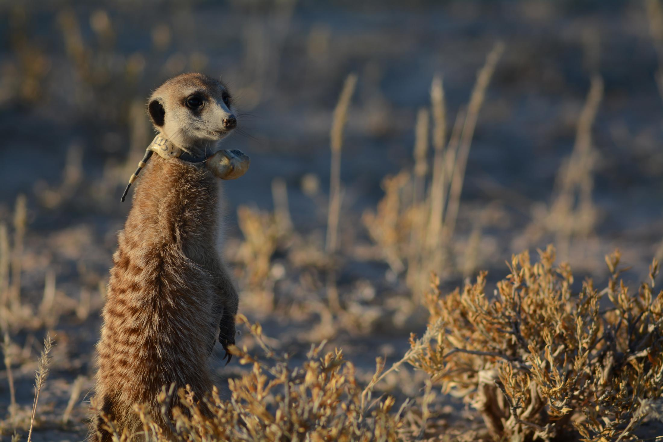

**battery**

**GPS**

**unit**

**antenna**

*Focal recordings of untagged individuals and scans*

Some non-juvenile individuals that could not be collared via the methods described above were instead continuously recorded by a human observer. A GPS tag equivalent to those deployed in collars was strapped to a directional microphone on the end of a telescopic pole and kept within 1 meter of the foraging meerkat for the duration of each session. At the same time, the observer vocally described the focal meerkat’s behavior using a handheld microphone, including noting occasional moments when the meerkat went out of range of the pole (these portions were then removed from the recorded trajectories). The numbers of meerkats which could be focal-followed in this way depended on the number of observers available (never more than 3), therefore not every non-juvenile could be recorded on every day, especially as GPS tags started failing due to low battery towards the end of each deployment round. We processed the data of focal followed individuals in the same way as data from meerkats wearing collars (see below).

During the recording session, an observer also noted the times of any group-level disturbances on an all-occurrence basis (predator alarm, encounter with another group, etc…), and these events were removed from the dataset in subsequent analyses (see below).

*Data pre-processing*

GPS Coordinates were first converted from WGS84 to UTM S34 to allow for easier spatial analyses. To increase GPS reliability and reduce sampling biases, we performed minimal pre-processing of GPS data before subsequent analysis. Speicifically, when GPS signals were not recorded continuously we discarded all fixes taken 30s before signal loss and 30s after signal retrieval, as these positions tended to be unreliable. We also removed fixes with fewer than 5 satellites detected.  Finally, we removed data suggesting unrealistic speeds (> 10 m displacement between 2 fixes 1 second apart) as these likely represented GPS errors.

Moments when fewer than 2/3 of the non-juveniles present were recorded were excluded from our analyses to reduce the impacts of “invisible” (untracked) individuals. We also removed predator alarms and one instance of encounter with another group identified using observational data, as these specific contexts are likely to be non-representative of typical meerkat group movement during foraging. In some instances, single individuals were away from the rest of the group during recording times, either at the communal burrow babysitting pups or out travelling on their own (“roving” behavior exhibited by adult males before dispersal from their natal territory). In such instances the GPS trajectory of that given individual was discarded but the analyses were performed normally on the rest of the group. One additional day was removed from the analysis of HM19 because the dominant male and two other adult males were not present with the group, thus potentially disrupting normal dynamics.

**Analysis**

*General explanation of the approach:*

To quantify individual influence from movement data, we defined a set of complementary metrics designed to capture influence over group direction (*turning influence*) and influence over group speed (*speeding influence*) separately, while also accounting for two different possibilities for how individuals influence the group (either by their relative *position* or by their relative *movement*). For each influence metric, we measure the probability that the group’s movement “follows” a given individual’s position or movement in the past, thus capturing the extent to which each individual “leads” the group. Each metric also captures how these probabilities change as a function of how extreme an individual’s position or movement is relative to the group. We give a short general description of the approach here, with additional details described in the next section.

**Position turning influence** is defined as the probability that the group turns in a given direction (right or left) as a function of an individual’s position to the left or right of the group center, and can be interpreted as answering the question “how does the left-right *position* of a given individual influence the group’s direction of travel?”. M**ovement turning influence** is defined as the probability that the group turns in a given direction as a function of the focal individual’s speed along the left-right axis of movement, and answers the question “how does the left-right *movement* of a given individual influence the group’s direction of travel?”. Similarly, **position speeding influence** is defined as the probability that the group speeds up as a function of the front-back position of an individual, answering the question “how does the front-back position of a given individual influence group speed?”. Finally, **movement speeding influence** is defined as the probability that the group speeds up as a function of the difference between individual and group speed along the front-back axis of movement, answering the question “how does the front-back movement of a given individual influence group speed?”.

For each individual and each metric, we fit a curve to describe the relationship between its position / movement and the group’s subsequent movement, using a slightly modified version of a logistic function. We then used these models to attribute an “influence score” to each individual for each of the four metrics. Finally, we fit Generalized Linear Mixed Models (GLMMs) to compare the values of each influence score between classes.

*Detailed explanation of the approach:*

To compute the influence metrics of all recorded individual within each of the five groups, we carried out the following procedure:

We first computed the group’s centroid track by averaging the position of all individuals recorded (other than the focal individual whose influence we were assessing) at each time point (figure 2a). For every time point *t*, we then calculated the *future* and *past* velocity vectors of the group centroid (figure 2b). The *future velocity vector* was defined as the vector pointing from the position at time *t* (henceforth ‘current position’) to the next recorded position that was at least 10 meters away (henceforth ‘future position’). The *past velocity vector* was defined as the vector pointing to the position at time t (henceforth current position) from the most recent position that was at least 10 meters away (henceforth ‘past position’). We chose to use spatial rather than temporal thresholds to define these headings because of the typical stop-and-go nature of meerkat movement, which makes the temporal scale at which movements occur highly variable. Such a spatial approach also avoids introducing noise in the headings due to small fluctuations in the GPS data when groups are relatively stationary (Farine et al. 2017). We chose 10 meters as the step length for spatial discretization as this reflects a biologically meaningful spatial scale for the system. To check for robustness, we repeated the analysis with thresholds of 5, 15 and 20 meters and obtained broadly similar results (see Supplement).

For each time step, the movement of the group was defined as either turning left or turning right (future direction of travel), and either speeding up or slowing down (future speed of travel), based on the relative difference between the group centroid’s future and past velocity vectors.

The group centroid’s current position and the group centroid’s past velocity vector were also used to define the x-axis of an orthonormal basis relative to which the position and movement of the focal individual could be computed (henceforth group reference frame, figure 2c). The group reference frame was thus defined such that the direction of motion pointed along the x axis in the positive direction, with the y axis representing the left-right axis of the group.

We also calculated the past velocity vector of the focal individual at each time point, defined in the same way as for the group past velocity vector, and projected it into the group reference frame to describe the individual’s position and movement relative to the group. From this, we computed four variables corresponding to the four different metrics of influence:

* the y-value of the individual’s past position (=left-right position, corresponding to **position turning influence**)
* the y component of the individual’s past velocity vector (=left-right movement, corresponding to **movement turning influence**)
* the x-value of the individual’s past position (=front-back position, corresponding to **position speeding influence**)
* the difference between the x component of the centroid’s past velocity vector and the x component of the individual’s past velocity vector (=front-back movement, corresponding to **movement speeding influence**)

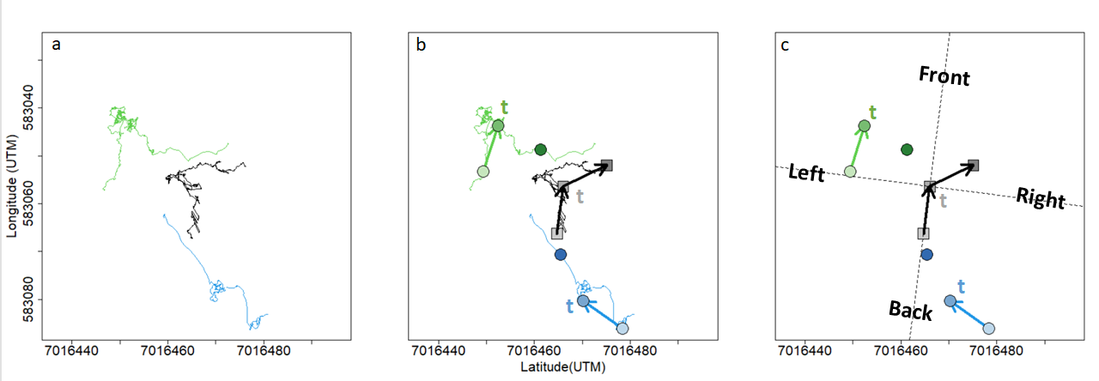Figure 2. Summary of data processing for a given time point. (a) Portions of meerkat movement trajectories collected from GPS collars. Green and blue lines represent the trajectories of two example individuals over a 20 minute interval. Black line represents the trajectory of the group centroid over the same time-interval, obtained by averaging the coordinates of every individual in the group (only two individuals represented here for clarity). (b) At time t, velocity vectors are calculated from the points 10 meters in the past and 10 meters in the future. Lighter symbols represent positions earlier in time, darker ones represent symbols later in time. (c) The velocity vector of the centroid from the past is used to define an orthonormal basis (dashed line) relative to which the position and movement of all individuals are calculated. Based on the centroid velocity vector from the future, the group is defined as either turning left or turning right, and either speeding up or slowing down at time t. Influence metrics are derived from the individual velocity vectors from the past. In this example, the blue individual would have a positive position turning influence at time t because it was on the right side of the group before the group turned right, but a negative movement turning influence because it was moving towards the left before the group turned right. It is the opposite for the green individual.

Exploratory analyses showed that the probability of the group to turn right increased sharply as individual position or movement towards the right increased, before plateauing, and conversely for movement toward the left, resulting in a sigmoid-like curve (Figure 3). A similar shape was observed for speeding influence (see supplements). For each type of influence, we therefore modelled the probability of a binary group response (turn left / right, speed up / slow down) as a function of a continuous individual predictor (position or movement relative to the group reference frame). In particular, (1) position turning influence is the probability of the group to turn right as a function of an individual’s left-right position, (2) movement turning influence is the probability of the group to turn right as a function of an individual’s speed along the group’s left-right axis, (3) position speeding influence is the probability of the group to speed up as a function of an individual’s position along the group’s front-back axis, and (4) movement speeding influence is the probability of the group to speed up as a function of the difference speed between an individual and the group group along the group’s front-back axis.

To model these probabilities, we fit a modified version of the logistic function to each of the four types of influence, for each individual (equation 1):

Here, *x* represents the individual characteristic (relative position or speed) and *f(x)* represents the probability of the group turning right or speeding up. α and β are variable parameters which were fit for each individual separately, while γ is a fixed parameter which we set as described below. α can be interpreted as the probability that the group is influenced by the focal individual at a given time point, β as the logistic growth rate (steepness) of the curve and hence the strength of influence, and γ as the baseline probability of the group either turning right or speeding up. In other words, we can consider that the group movement outcome (either turning left/right or speeding up/slowing down) has a probability α to be influenced by a given individual, in which case it follows a standard logistic function (first term of the equation), or is decided regardless of the position or movement of the focal individual, with a probability (1- α). For the two turning influence metrics, γ was set to 0.5 (assuming an overall equal probability to turn left or right). For the two speeding influence metrics, γ was fixed to the aggregate probability of a given group to speed up over all the data. Because groups tend to accelerate in rapid bursts but decelerate over longer time periods, the overall probability of a group speeding up is lower than the probability of the group slowing down, hence the value of γ was not 0.5.

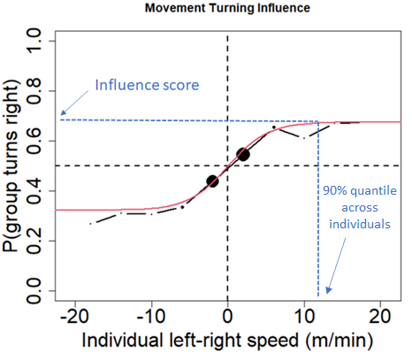We computed the fitted values of α and β for each of the four influence metrics, for each individual using maximum likelihood estimation. This enabled us to define, for each individual, a curve representing its influence for each of the four types of influence. For ease of interpretation and subsequent modeling, we also defined an aggregate “influence score” for each individual and each type of influence. We defined the aggregate “influence score” as the value of the individual’s fitted curve at the 90% quantile of each of the four continuous predictor variables across all individuals (figure 3). This influence score therefore corresponds to the probability that the group is positively influenced by the focal individual for a fixed value of position or speed relative to the group centroid.

Figure 3. Example for one given individual of the probability that the group turns right relative to its past direction of travel as a function of that individual speed along the left-right axis. Positive x-values indicates that the individual was moving towards the right of the group relative to past direction of travel, negative values indicate it was moving towards the left. Black curve shows the data (binned every 4 x-units), red curve shows the fitted line from the model. Blue dotted lines show how the influence score is found for that individual.

To test if there were consistent differences in influence based on individual status, we fitted GLMMs to predict influence score as a function of status (dominant female, dominant male, adult, sub-adult, juvenile), for each of the types of influence. Each individual was considered as one data point in the models, and we included group as a random effect to control for non-independence of data within each group.

To test whether an individual’s position and movement interacted to shape its influence, and to measure the relative strength of these two cues in influencing group movement, we modelled the probability of the group to turn right as a function of both individual left-right position and individual left-right movement within the same model. Similarly, we also modeled the probability of the group to speed up as a function of both individual front-back position and individual front-back movement (equation 2). For these fits, we aggregated data across all individuals instead of performing fits separately for each individual. The following equation expresses the probability of the group turning right (or speeding up) as a function of individual relative position (*x1*) and movement (*x2*), with the fitted β parameters representing the extent to which position and movement influence the group response.

*Proportion of time in the front:*

To assess whether individuals differ in their propensity to be at the front of the group, we quantified for each individual the distribution of front-back position relative to the group direction of travel. We also calculated the proportion of time each individual spent in the front half of the group, as a simple metric of ‘frontness’, to allow comparison with our influence scores. At time t, a given individual was considered in the front half of the group if its front-back position (x-value within the centroid reference frame, see above) was positive. In order to see the variation in the propensity to be in the front between individuals and across groups, we computed the proportion of time points an individual was in the front half in time segments of one hour.

To test whether individuals at the front of groups have greater influence, we computed the correlation (Spearman?) between the total proportion of time spent in the front for each individual and their turning and speeding influence scores.

**RESULTS**

**Influence of individual position vs individual movement on subsequent group behavior:**

Using the model described by equation 2, we found that across all individuals, though individual left-right position was positively associated with the probability of the group to turn right, individual left-right speed had a much greater influence (figure 4a). In other words, the probability of the group to turn right increases more as an individual’s movement towards the right increases, than as an individual’s position along the left-right axis increases. Similarly, the probability of the group to speed up was influenced more by individual front-back movement than by individual front-back position (figure 4b.) These results suggest that an individual’s movement is a more important cue than its position in influencing the rest of the group’s direction and speed. Because of this finding, we focus on movement turning and speeding influence rather than on position turning and speeding influence for subsequent analyses, however we present the results for position turning and speeding influence in the Supplement.

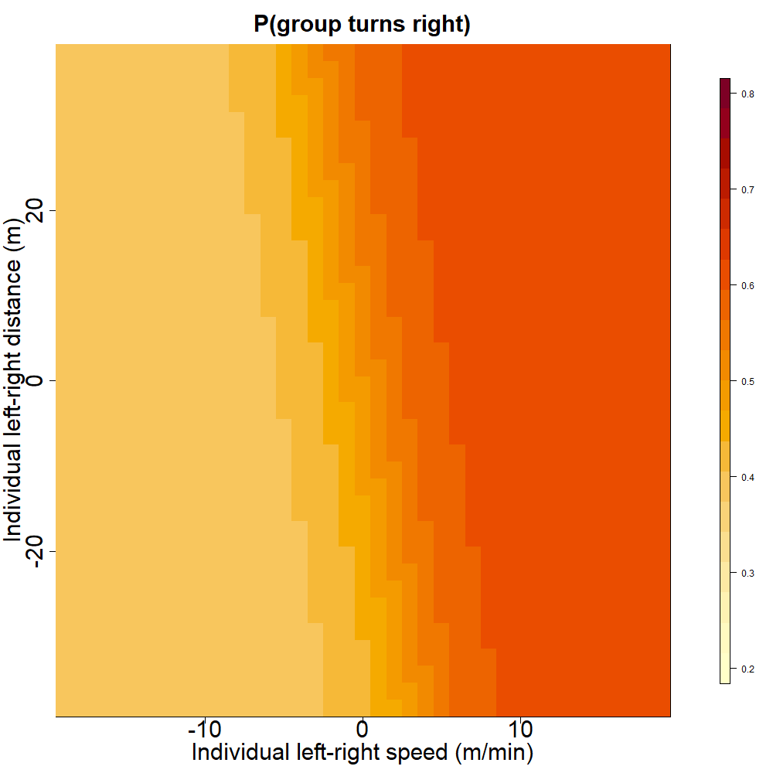

a.

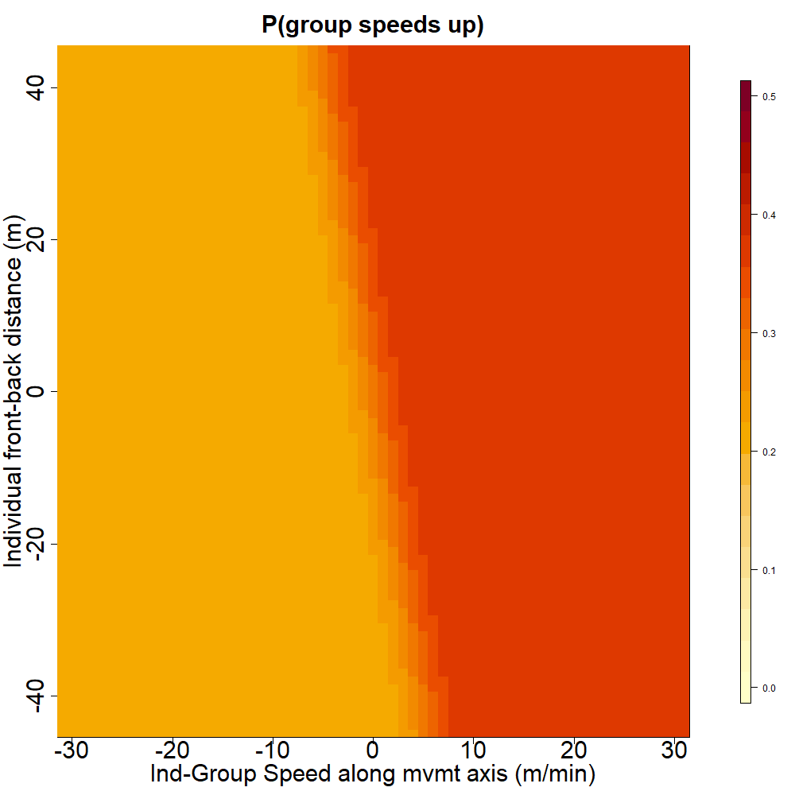

b.

Figure 4. (a) Turning influence: Probability that the group turns towards the right relative to its past direction of movement as a function of individual left-right position and left-right movement. (b) Speeding influence: Predicted probability that the group speeds up relative to its past speed, as a function of individual position and group-individual difference in speed along the front-back axis of travel. Extent of the axes correspond to the 99% quantiles of the variables across all indviduals (hence they are on comparable scales).

**Does an individual’s status predict its influence score?**

We found a significant effect of status on movement turning influence score (figure 5a, F = 5.19 ; DF = 40 ; p-value = 0.0018), with the dominant female’s score consistently being the highest or second highest of her group across all 5 groups. Post-hoc Tukey tests (see Supplement) showed that the score of dominant females was overall significantly higher than the scores of each subordinate status (non-dominant adults, yearlings and sub-adults), whereas the score of the dominant male was not significantly different from the scores of subordinate statuses.

There also was a significant difference between the movement speeding influence score of different statuses (figure 5b, F = 3.95 ; DF = 40 ; p-value = 0.0086). Post-hoc Tukey tests (see supplements) showed that the score of dominant females was significantly higher than the score of yearlings and sub-adults but was not significantly different from the score of dominants males and non-dominant adults. The score of the dominant male was not significantly different from the scores of subordinate statuses.

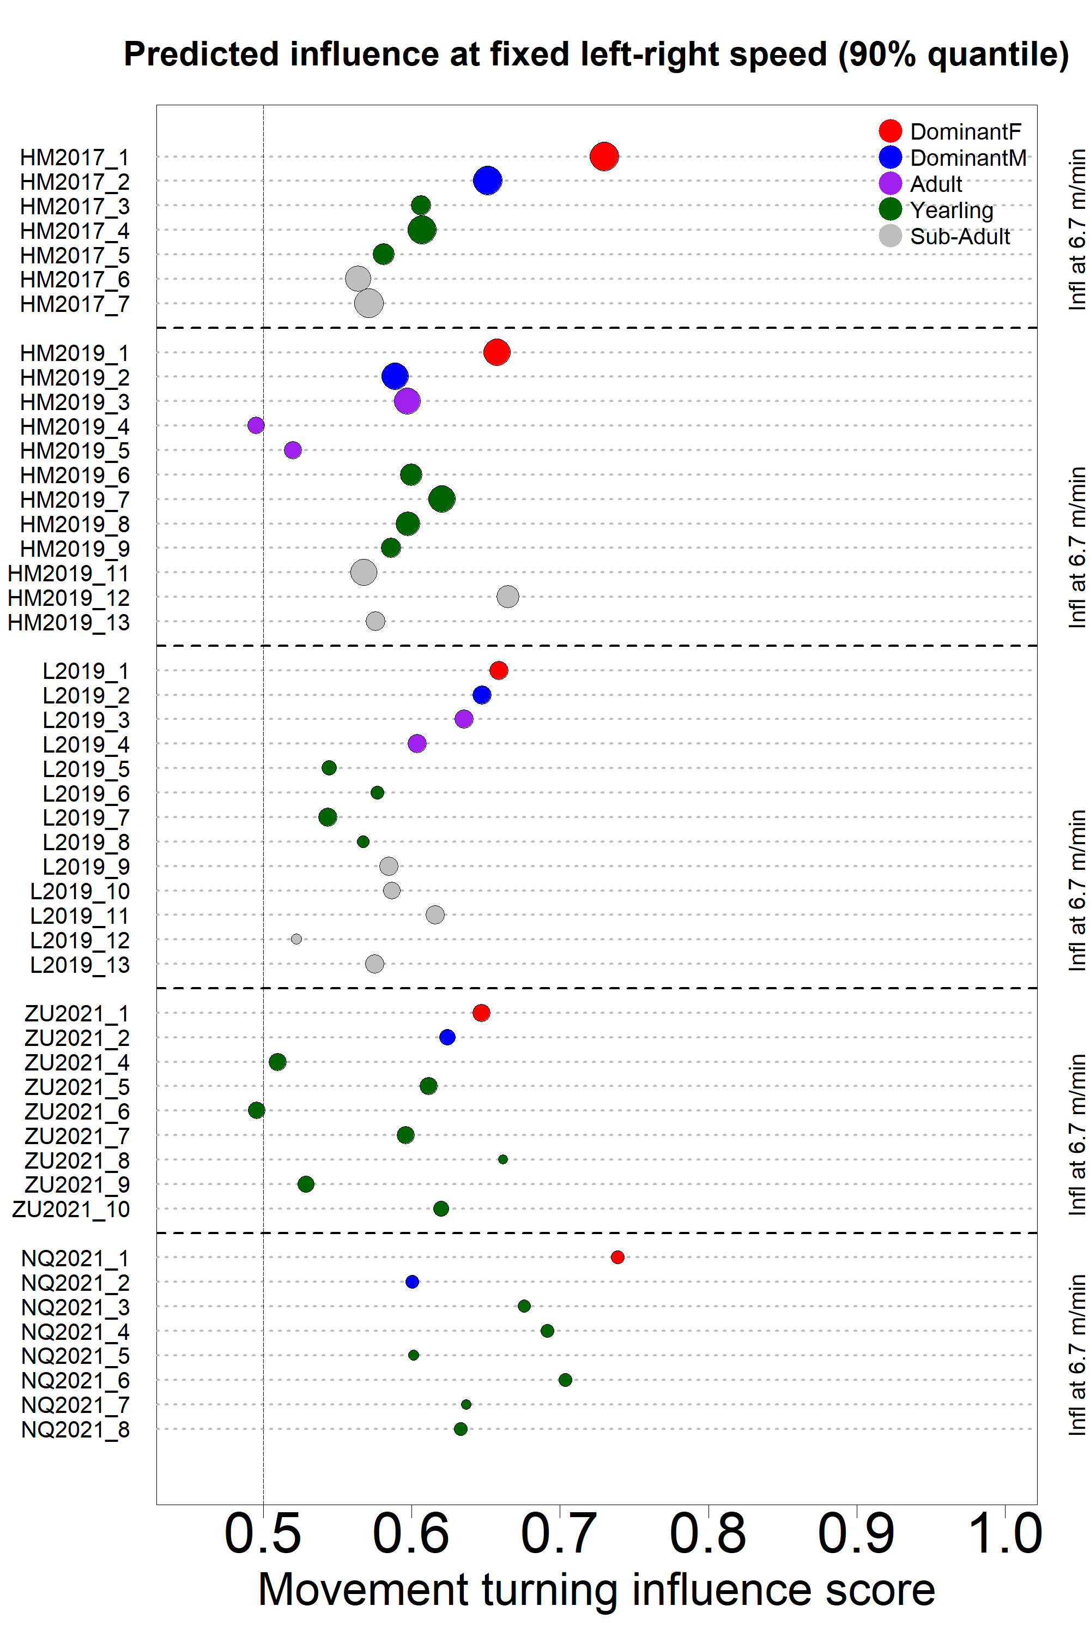

**a.**

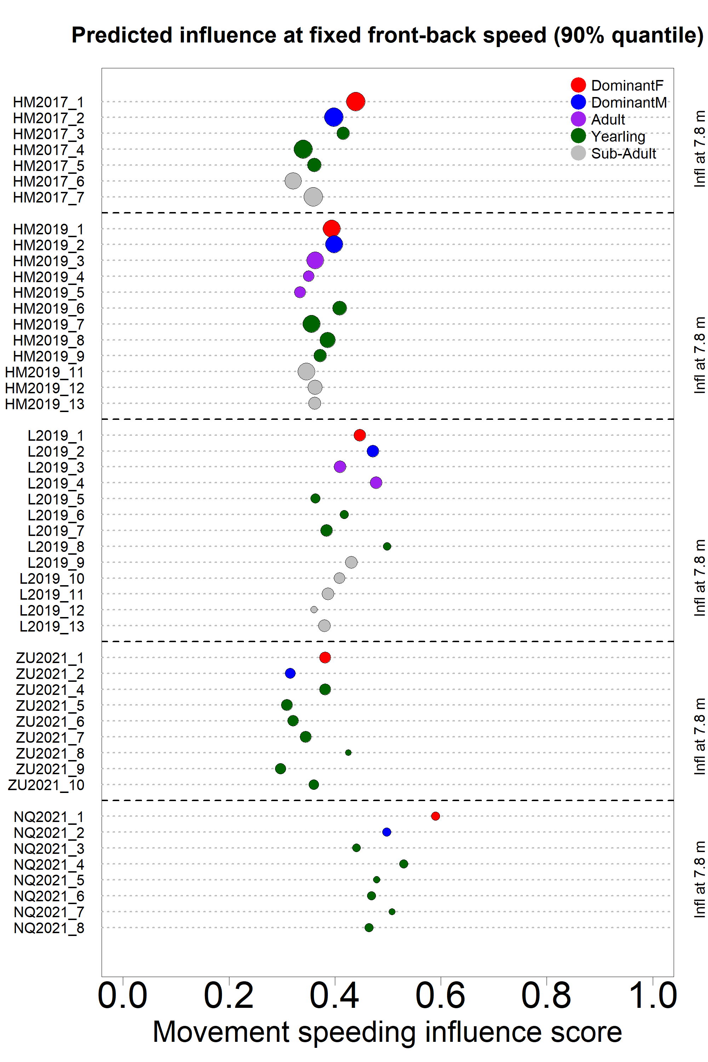

**b.**

Figure 5. Iinfluence scores (x axis) for each recorded individual (y axis) in the 5 study groups (separated by dashed lines). Dot color indicates individual status as shown in the legend. Dot size is proportional to the quantity of data available. (a) Turning influence score represents the probability that the group turned toward the same direction (left or right) that individual was moving. (b) Speeding influence score represents the probability that the group speeds up after that individual was moving faster than the group.

**Influence vs time spent in the front:**

The proportion of time spent in the front of the group by individuals in each status class varied between groups (figure 6). The overall proportion of time spent in the front half by the dominant female was the highest in two groups (HM17 and HM19), the second highest in one group (NQ21), and the lowest in one group (ZU21). In contrast, the dominant male was more often in the back half of the group, except in L2021. No overall trend seems to emerge for other statuses.

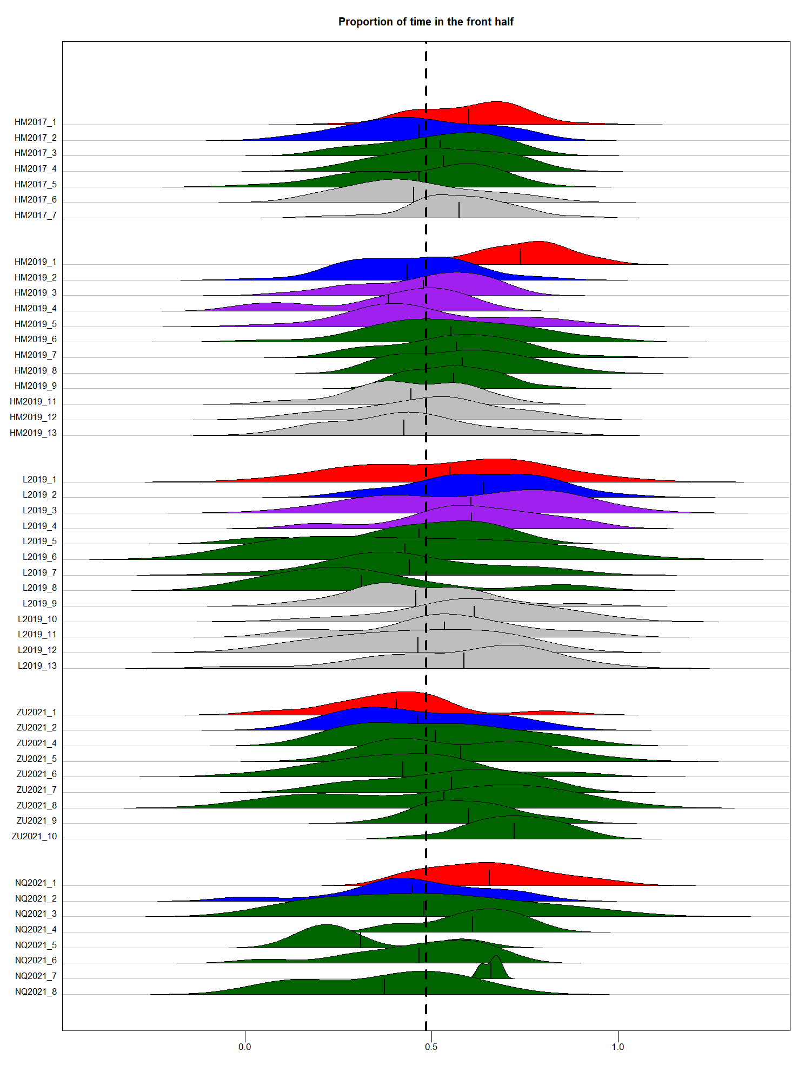

Figure 6. Distribution of the proportion of time points spent in the front half of the group over one-hour time period, for each individuals in the 5 study groups (vertical axis). Shape color indicates individual status as shown in the legend. Black vertical lines within each shape indicates the overall mean proportion of time spent in the front half of the group for that individual. Vertical dotted line indicates equal amount of time spent in the front and in the back half of the group.

We found a significant positive correlation between individual movement turning influence score and overall proportion of time spent in the front half (figure 7.a, F=6.039 ; DF = 47 ; p-value = 0.018). There was no significant correlation between individual movement speeding influence and overall proportion of time spent in the front half (figure 7.a, F=0.628 ; DF = 47 ; p-value = 0.432).

Figure 7. Individual movement turning influence score (a) and movement speeding influence score (b) as a function of overall proportion of time spent in the front half of the group. Each dot represents one individual, with color indicating status and shape indicating group.

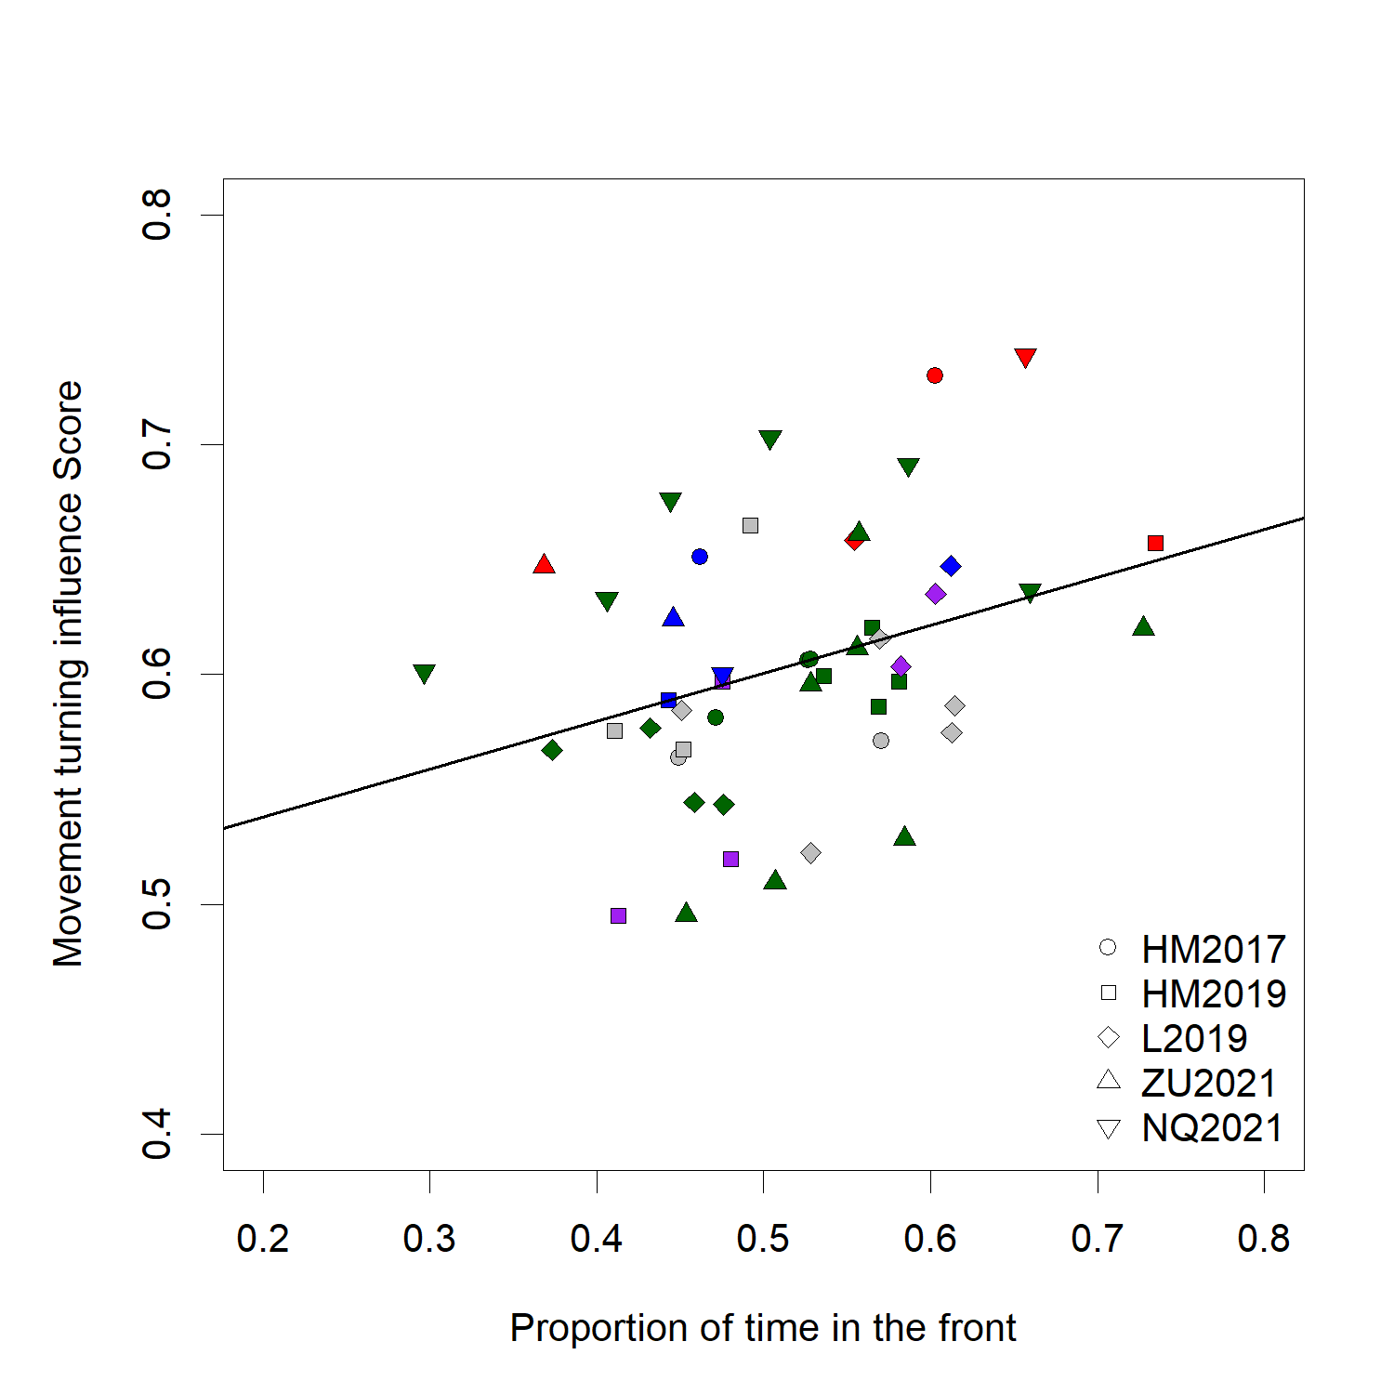

**a.**

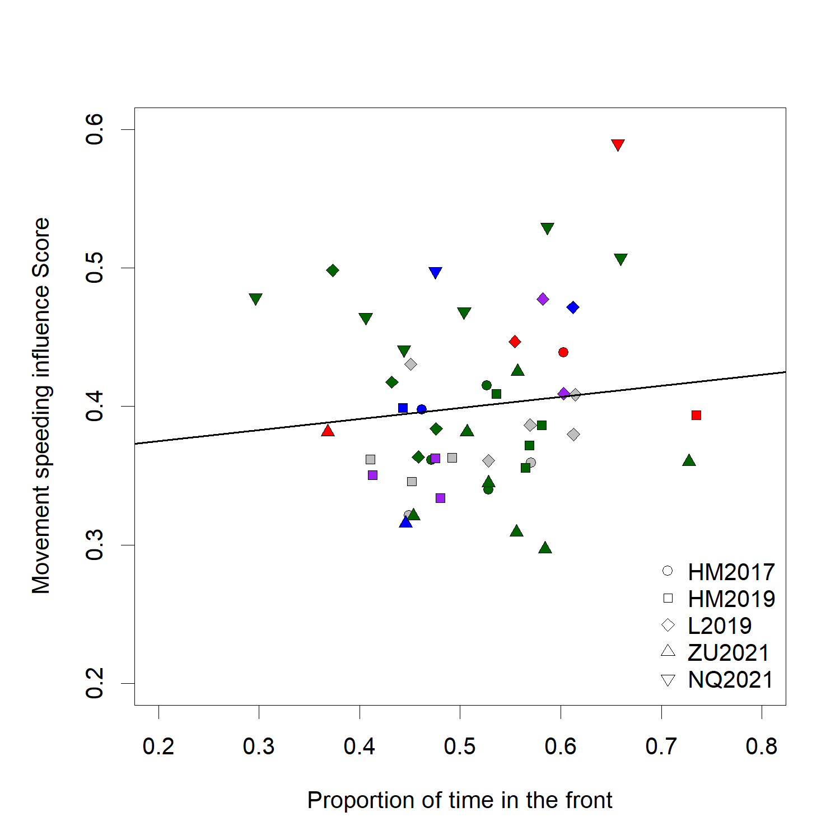

**b.**

**DISCUSSION**

Using a suite of metrics to quantify influence, we analyze high-resolution tracking data across five different social groups to reveal a complex and nuanced picture of how influence is distributed in meerkat social groups. Our results show that both the position of individuals relative to others and their movement in particular directions are linked with subsequent changes in the direction and speed of the rest of the group. However, we found that overall an individual’s movement is more important than its position in predicting which direction a group will move next, or when it will accelerate. Though classical models of collective movement (REF) or controlled studies of moving animal groups (REF) often find individual position to be an important predictor of where other individuals are going to be moving next, our findings make sense in the light of the particular type of movement exhibited by meerkat groups. Indeed, contrary to animals in the studies cited above which tend to be always in polarized motion and for which therefore position is a strong indicator of direction, a lot of the time each individual meerkat is foraging independently from others while the group as a whole is relatively stationary. Thus, their current position in the group doesn’t necessarily entail the direction where they want to go next. Rather, our results indicate that meerkat’s likelihood to influence the group’s direction of movement increases with the speed at which they move in that particular direction. Individuals therefore likely draw information more from the movement than the location of others.

Across the 5 social groups we monitored, the dominant females represented clear outliers in terms of turning influence. Dominant females had significantly higher movement turning influence, meaning that the rest of the group was more likely to follow her movement direction than any of the other statuses. Dominant males on the other hand were not significantly more likely to attract the other members of the group than the other status categories. One hypothesis as to why dominant females may control group direction more than dominant males is that they have more experience within the territory. Meerkat group territories usually vary little within the course of individuals’ lives (Kranstauber et al. 2019), therefore individuals who have spent more time within a given group are the most experienced ones in terms of navigating within this group’s home range, and should thus be more likely to be followed by other less experienced individuals. Because meerkat males disperse when they reach sexual maturity, dominant males, though often older than their female counterparts, are typically non-natal and hence have usually not spent as much time in the group territory (S.P. Doolan and Macdonald 1996; Griffin et al. 2003; Mares et al. 2014). As a consequence, dominant females are usually the eldest natal individuals of their groups. This was the case for all five groups we studied here, with the exception of NQ21, where 2 subordinate individuals were born in the same litter as the dominant female (NQ2021_3 and NQ2021_4), and it is noteworthy that they too had fairly high turning influence scores. It is however surprising that we found no differences in turning influence between subordinate statuses (non-dominant adults, yearlings, and sub-adults), as according to our reasoning older statuses would be expected to have more influence. It is thus likely that knowledge of the home range, in combination with dominance status, are aspects significantly contributing to increase a meerkat’s influence on the group’s direction of movement. These results also highlight the benefits provided by the availability of long-term data in interpreting short-term movement dynamics.

Individuals with high movement turning influence also tended to have high movement speeding influence (see supplements), but in contrast to turning influence, there were less striking differences between statuses in terms of speeding influence. In particular, all adult statuses (dominant female, dominant male and other adults) had a similar chance of speeding the group up when they were moving faster than the centroid, or slowing it down when moving slower than the centroid. The dominant female therefore seems to have more influence over the direction of travel of the group, than over its speed. Decisions about direction of movement and decisions about speed (i.e. timing) of movement usually differ in that the former are discrete whereas the latter are continuous (Conradt and Roper 2010). In the case of meerkats, this means that contrary to timing decisions, wrong decisions regarding the direction of movement could end up being very costly for all individuals in the groups, as they could end up in a location with little food, or no sleeping burrows, or in rival territories. Thus, it makes sense that influential individuals are more likely to emerge in decisions involving directions, in the traits of more experienced meerkats like the dominant female. Given our results, influence over group speed could be either distributed, with all or most adults contributing to the decision to speed up or not at a given moment, or varying in time between group members, with individuals taking turns influencing others to speed up or slow down. Unfortunately, our methodology does not allow us to disentangle between these two options. Because speed of the group could have repercussions on individuals’ ability to locate food, and because quorum mechanisms, akin to a voting process by which a certain threshold of individuals giving a specific type of call is required for the group to start moving, have already been shown in meerkats (Bousquet et al. 2011), in future works it could be very interesting to incorporate data about individual foraging success, as well as vocalizations, within our influence framework, to further our understanding of the interactions between these aspects.

The tendency to be in the front of the group is often taken as a proxy for leadership in studies of group movement. Here we did find a positive correlation between movement turning influence and proportion of time spent in the front half of the group. However when looking specifically at the status with the highest turning influence within their group, dominant females, we see that they are not necessarily more in the front than other members of the group. In particular, in L19, the dominant female spent a similar amount or less time in the front than many other individuals in her group, and in ZU21, she was the individual who spent the least amount of time in the front of the group, despite both of these dominant females having the highest turning influence scores of their groups. These results highlight that individuals in moving social groups don’t necessarily need to be at the front position in order to influence group direction. Being in the front is most likely to be linked with influence in environments where visibility is high and in species where information is transferred primarily through vision (e.g. fish, Strandburg-Peshkin et al. 2013; Rosenthal et al. 2015). However in the meerkats’ habitat, tall sour grass or bushes often impede visibility (REF), and meerkats are known to use a variety of vocalizations to coordinate movement [CITE]. Thus, they have the potential to convey information, and therefore influence others, from anywhere in the group. This decoupling of front position and influence over direction highlights that, depending on the species, the ordering of individuals along the axis of movement alone might not necessarily be a reliable metric to infer influence and should be used in complement with other metrics. Moreover, understanding when and how individuals are able to exert influence from the back of groups, and how this is linked to the mechanisms of information transfer employed, are important questions for future work. Interestingly, in our data the one dominant female that spent more time in the back (group ZU21) had by far the longest tenure at the time of data collection amongst dominant females of our study (104 weeks against 38 weeks maximum, sees supplements). This suggests the intriguing possibility that as a female’s dominance becomes better and better established within a group, she might become more and more able to influence the group from any position.

**CONCLUSION**

Overall our results show that meerkats seem to influence the direction and speed of the groups via their movement in certain directions more than via their relative positions within the group. Dominant females have the most influence over the direction of travel but not necessarily over speed of travel, highlighting the importance of disentangling these two components of influence even in groups where both operate concurrently. Furthermore, the finding that the most influential individuals are not always the ones located in the front of the group emphasizes the need to critically evaluate the common assumption that those at the front take the lead.

The methodological approach developed here is species-general and could be applied more broadly across different species, or under different environmental conditions, to disentangle influence over timing and directional decisions. Because our approach by design captures influence aggregated over time, it could be interesting in future work to contrast it with complementary approaches, for instance approaches that identify particular events in the trajectory such as sharp changes in direction or increases in speed during movement, in order to gain a more complete picture of the distribution and variability of influence in social groups. The method could also be used in combination with other features, such as vocalizations, to assess how such features impact influence dynamics. The results presented here highlight the complexity of the concept of influence, and demonstrate the need to study it from different perspectives across multiple groups to begin to reveal a more complete understanding of collective decision-making in animal societies.

**BIBLIOGRAPHY**

Bousquet CAH, Manser MB. 2011. Resolution of experimentally induced symmetrical conflicts of interest in meerkats. Animal Behaviour. 81(6):1101–1107. doi:10.1016/j.anbehav.2011.02.030.

Bousquet CAH, Sumpter DJT, Manser MB. 2011. Moving calls: a vocal mechanism underlying quorum decisions in cohesive groups. Proceedings of the Royal Society of London B: Biological Sciences. 278(1711):1482–1488. doi:10.1098/rspb.2010.1739.

Clutton-Brock TH, Brotherton PNM, O’Riain MJ, Griffin AS, Gaynor D, Kansky R, Sharpe L, McIlrath GM. 2001. Contributions to cooperative rearing in meerkats. Animal Behaviour. 61(4):705–710. doi:10.1006/anbe.2000.1631.

Clutton-Brock TH, Maccoll A, Chadwick P, Gaynor D, Kansky R, Skinner JD. 1999. Reproduction and survival of suricates (Suricata suricatta) in the southern Kalahari. African Journal of Ecology. 37(1):69–80. doi:10.1046/j.1365-2028.1999.00160.x.

Conradt L, Roper TJ. 2010. Deciding group movements: where and when to go. Behavioural processes. 84:675–677. doi:10.1016/j.beproc.2010.03.005.

Couzin ID, Krause J, Franks NR, Levin SA. 2005. Effective leadership and decision-making in animal groups on the move. Nature. 433(7025):513–516. doi:10.1038/nature03236.

Doolan S, Macdonald D. 1996. Diet and foraging behaviour of group living meerkats, Suricata suricatta, in the southern Kalahari. Journal of Zoology. 239:697–716.

Doolan SP, Macdonald DW. 1996. Dispersal and extra-territorial prospecting by slender-tailed meerkats (Suricata suricatta) in the south-western Kalahari. Journal of Zoology. 240(1):59–73. doi:10.1111/j.1469-7998.1996.tb05486.x.

Doolan SP, Macdonald DW. 1997. Breeding and juvenile survival among slender-tailed meerkats (Suricatu suricatta) in the south-western Kalahari: ecological and social influences. Journal of Zoology. 242(2):309–327. doi:10.1111/j.1469-7998.1997.tb05804.x.

Gall GEC, Manser MB. 2017. Group cohesion in foraging meerkats : follow the moving ‘ vocal hot spot ’. Royal Society Open Science.

Gall GEC, Strandburg-Peshkin A, Clutton-brock T, Manser MB. 2017. As dusk falls : collective decisions about the return to sleeping sites in meerkats. 132:91–99.

Garland J, Berdahl AM, Sun J, Bollt EM. 2018. Anatomy of leadership in collective behaviour. Chaos. 28(7):075308. doi:10.1063/1.5024395.

Giuggioli L, McKetterick TJ, Holderied M. 2015. Delayed Response and Biosonar Perception Explain Movement Coordination in Trawling Bats. PLOS Computational Biology. 11(3):e1004089. doi:10.1371/journal.pcbi.1004089.

Griffin AS, Pemberton JM, Brotherton PNM, McIlrath G, Gaynor D, Kansky R, O’Riain J, Clutton-Brock TH. 2003. A genetic analysis of breeding success in the cooperative meerkat (Suricata suricatta). Behavioral Ecology. 14(4):472–480. doi:10.1093/beheco/arg040.

Herbert-Read JE. 2016. Understanding how animal groups achieve coordinated movement. Journal of Experimental Biology. 219(19):2971–2983. doi:10.1242/jeb.129411.

Hughey LF, Hein AM, Strandburg-Peshkin A, Jensen FH. 2018. Challenges and solutions for studying collective animal behaviour in the wild. Phil Trans R Soc B. 373(1746):20170005. doi:10.1098/rstb.2017.0005.

Jolles JW, Boogert NJ, Sridhar VH, Couzin ID, Manica A. 2017. Consistent Individual Differences Drive Collective Behavior and Group Functioning of Schooling Fish. Current Biology. 27(18):2862-2868.e7. doi:10.1016/j.cub.2017.08.004.

Katz Y, Tunstrøm K, Ioannou CC, Huepe C, Couzin ID. 2011. Inferring the structure and dynamics of interactions in schooling fish. PNAS. 108(46):18720–18725. doi:10.1073/pnas.1107583108.

Kerth G, Ebert C, Schmidtke C. 2006. Group decision making in fission–fusion societies: evidence from two-field experiments in Bechstein’s bats. Proceedings of the Royal Society B: Biological Sciences. 273(1602):2785–2790. doi:10.1098/rspb.2006.3647.

Kranstauber B, Gall GEC, Vink T, Clutton‐Brock T, Manser MB. 2019. Long-term movements and home-range changes: Rapid territory shifts in meerkats. Journal of Animal Ecology. n/a(n/a). doi:10.1111/1365-2656.13129. [accessed 2019 Dec 19]. https://besjournals.onlinelibrary.wiley.com/doi/abs/10.1111/1365-2656.13129.

Lewis JS, Wartzok D, Heithaus MR. 2011. Highly dynamic fission–fusion species can exhibit leadership when traveling. Behav Ecol Sociobiol. 65(5):1061–1069. doi:10.1007/s00265-010-1113-y.

Manser MB, Clutton‐Brock TH. 2016. Meerkats: cooperative breeding in the Kalahari. In: Koenig WD, Dickinson JL, editors. Cooperative Breeding in Vertebrates. Cambridge University Press.

Manser MB, Jansen DAWAM, Graw B, Hollén LI, Bousquet CAH, Furrer RD, le Roux A. 2014. Vocal Complexity in Meerkats and Other Mongoose Species.

Mares R, Bateman AW, English S, Clutton-Brock TH, Young AJ. 2014. Timing of predispersal prospecting is influenced by environmental, social and state-dependent factors in meerkats. Animal Behaviour. 88:185–193. doi:10.1016/j.anbehav.2013.11.025.

Montanari D, O’Hearn WJ, Hambuckers J, Fischer J, Zinner D. 2021. Coordination during group departures and progressions in the tolerant multi-level society of wild Guinea baboons (Papio papio). Sci Rep. 11(1):21938. doi:10.1038/s41598-021-01356-6.

Nagy M, Ákos Z, Biro D, Vicsek T. 2010. Hierarchical group dynamics in pigeon flocks. Nature. 464(7290):890–893. doi:10.1038/nature08891.

Papageorgiou D, Farine DR. 2020. Shared decision-making allows subordinates to lead when dominants monopolize resources. Science Advances. 6(48):eaba5881. doi:10.1126/sciadv.aba5881.

Pettit B, Ákos Z, Vicsek T, Biro D. 2015. Speed Determines Leadership and Leadership Determines Learning during Pigeon Flocking. Current Biology. 25(23):3132–3137. doi:10.1016/j.cub.2015.10.044.

Rosenthal SB, Twomey CR, Hartnett AT, Wu HS, Couzin ID. 2015. Revealing the hidden networks of interaction in mobile animal groups allows prediction of complex behavioral contagion. PNAS. 112(15):4690–4695. doi:10.1073/pnas.1420068112.

Smith JE, Estrada JR, Richards HR, Dawes SE, Mitsos K, Holekamp KE. 2015. Collective movements, leadership and consensus costs at reunions in spotted hyaenas. Animal Behaviour. 105:187–200. doi:10.1016/j.anbehav.2015.04.023.

Strandburg-Peshkin A, Clutton-Brock T, Manser MB. 2020. Burrow usage patterns and decision-making in meerkat groups. Behavioral Ecology. 31(2):292–302. doi:10.1093/beheco/arz190.

Strandburg-Peshkin A, Clutton-Brock T, Manser MB. 2019. Burrow usage patterns and decision-making in meerkat groups. Behav Ecol. doi:10.1093/beheco/arz190. [accessed 2019 Nov 8]. https://academic.oup.com/beheco/advance-article/doi/10.1093/beheco/arz190/5613753.

Strandburg-Peshkin A, Farine DR, Couzin ID, Crofoot MC. 2015. GROUP DECISIONS. Shared decision-making drives collective movement in wild baboons. Science. 348(6241):1358–1361. doi:10.1126/science.aaa5099.

Strandburg-Peshkin A, Papageorgiou D, Crofoot MC, Farine DR. 2018. Inferring influence and leadership in moving animal groups. Philosophical transactions of the Royal Society of London Series B, Biological sciences. 373(1746):20170006–20170006. doi:10.1098/rstb.2017.0006.

Strandburg-Peshkin A, Twomey CR, Bode NWF, Kao AB, Katz Y, Ioannou CC, Rosenthal SB, Torney CJ, Wu HS, Levin SA, et al. 2013. Visual sensory networks and effective information transfer in animal groups. Current Biology. 23(17):R709–R711. doi:10.1016/j.cub.2013.07.059.

Tokuyama N, Furuichi T. 2017. Leadership of old females in collective departures in wild bonobos (Pan paniscus) at Wamba. Behav Ecol Sociobiol. 71(3):55. doi:10.1007/s00265-017-2277-5.

Van Belle S, Estrada A, Garber PA. 2013. Collective group movement and leadership in wild black howler monkeys (Alouatta pigra). Behav Ecol Sociobiol. 67(1):31–41. doi:10.1007/s00265-012-1421-5.